44.13: a) 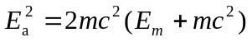
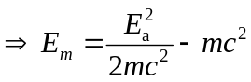
The mass of the alpha particle is that of aHe atomic mass, minus two electron masses. But to 3 significant figures this is just
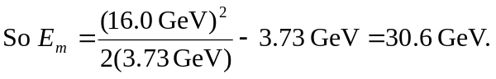
b) For colliding beams of equal mass, each has half the available energy, so each
has 8.0 GeV.

